**Symbolic**

**Hello chat, I am a Math teacher and I teach 11 and 12-year-old pupils in Germany. I will give you the tasks try to solve them and write the explanation so 11 and 12-year-olds can understand it. I will use Symbolic Chain-Of-Thought Prompting, answer me in accordance with this.**

ChatGPT

Memory updated  
ChatGPT

Got it! Please go ahead and share the first task, and I'll solve it using Symbolic Chain-Of-Thought Prompting with simple explanations for your students.

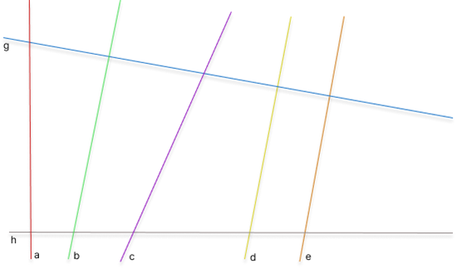  
**1. Which of the lines are perpendicular to each other? If the particular line is a straight line that makes the right angle (90 degrees) with the other line check with the triangle ruler which of the lines are perpendicular to each other? Example is: a ⊥ g.**

ChatGPT

I see that you've uploaded an image with several lines. The task is to find which of the lines are perpendicular to each other.

Perpendicular lines are lines that meet at a right angle (90 degrees). To solve this:

1. Use a triangle ruler or protractor to check if two lines intersect at a right angle.
2. If they form a right angle, we can say they are perpendicular to each other.

Looking at the image, I can guide the reasoning but can’t physically check the angles in the image for you. If you have a triangle ruler or a protractor, check the angles where two lines intersect.

In this case, you mentioned that line **a** is perpendicular to line **g**, which means they form a 90-degree angle. Similarly, you can check other pairs by following this method.

If you prefer me to visually analyze it, you can describe the position or orientation of the lines in the image, and I will give you more help on that!

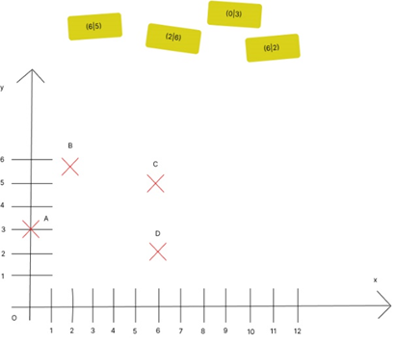  
**2. Arrange the cards to the shown dots. If we know that we can arrange dots by drawing and plotting the points how would you arrange the cards?**

ChatGPT

Looking at the graph, we need to match the yellow cards (which have coordinates written on them) to the points marked on the graph (A, B, C, and D).

Let’s solve it step by step:

**Step 1: Understand the Coordinates**

Each yellow card has a pair of numbers (x, y), where:

* The first number (x) represents the position along the horizontal (x-axis).
* The second number (y) represents the position along the vertical (y-axis).

The cards are:

* (6, 5)
* (2, 6)
* (0, 3)
* (6, 2)

**Step 2: Plot the Coordinates to Match the Dots**

* **Card (6, 5)**: This means go to x = 6 and y = 5. Check the graph and see which point is at (6, 5). This point matches **Point C**.
* **Card (2, 6)**: This means go to x = 2 and y = 6. This point matches **Point B**.
* **Card (0, 3)**: This means go to x = 0 and y = 3. This point matches **Point A**.
* **Card (6, 2)**: This means go to x = 6 and y = 2. This point matches **Point D**.

**Step 3: Final Arrangement**

* (6, 5) → Point C
* (2, 6) → Point B
* (0, 3) → Point A
* (6, 2) → Point D

That's how you can arrange the cards to the points shown on the graph!

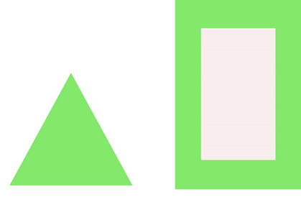

**Prompt: Transfer the figures into your notebook and mark the axes of symmetry. If we know that we can find symmetry by drawing a vertical line through the center or by a horizontal line through the marked center, how would you check and mark the axes of symmetry? Draw it.**

ChatGPT

To check and mark the axes of symmetry for the given shapes, let's go through each figure step by step:

**Step 1: The Triangle**

* A regular triangle (equilateral triangle, as it appears in the image) has **3 axes of symmetry**.
* You can find the symmetry by drawing straight lines through the center of the triangle that pass through one vertex and the midpoint of the opposite side. These lines divide the triangle into equal halves.

In your notebook, mark the axes of symmetry like this:

* Draw a line from the top vertex to the middle of the base.
* Then, draw two more lines from the other vertices to the middle of their opposite sides.

**Step 2: The Rectangle within a Green Border**

* A rectangle has **2 axes of symmetry**: one vertical and one horizontal.
  + The **vertical line of symmetry** cuts the rectangle into two equal halves from top to bottom.
  + The **horizontal line of symmetry** cuts the rectangle into two equal halves from side to side.

In your notebook, draw these axes:

* Draw one vertical line through the center (from the middle of the top to the bottom).
* Draw one horizontal line through the center (from the middle of the left side to the right side).

**Summary:**

* The triangle will have 3 symmetry lines.
* The rectangle will have 2 symmetry lines (one vertical and one horizontal).

This is how you can mark the axes of symmetry for these shapes!

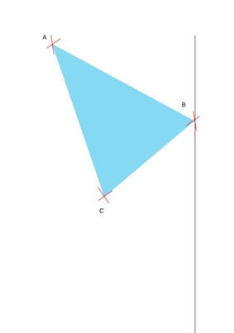

**4 .Complete the figure to make it axially symmetrical. The red line is the axis of symmetry. If we know that we can find axial symmetry by drawing the triangle equal on it sides. how would you complete the figure? Draw it.**

ChatGPT

To complete the figure and make it axially symmetrical, we will reflect the triangle across the red line (the axis of symmetry). Here’s the step-by-step process:

**Step 1: Identify the Points and Reflect**

* The red line represents the axis of symmetry, which means any point on one side of the line must have a mirror image on the opposite side.
* To reflect the triangle, you need to measure the perpendicular distance from each vertex (A, B, and C) to the red line. Then, place the reflected points on the other side of the line at the same distance.

**Step 2: Reflect Each Vertex**

* **Point A**: Measure the distance from point A to the red line. On the opposite side, place a point the same distance away, in a straight line perpendicular to the axis.
* **Point B**: Since point B is on the red line, its reflection will be right on top of it.
* **Point C**: Measure the distance from point C to the red line, and place a point on the opposite side at the same distance.

**Step 3: Complete the Triangle**

Once you have the reflected points, connect the reflected points in the same way as the original triangle to form the symmetrical figure. The new triangle will be an exact mirror image of the original triangle, with the red line acting as the line of symmetry.

By completing these steps in your notebook, you will have created an axially symmetrical figure.

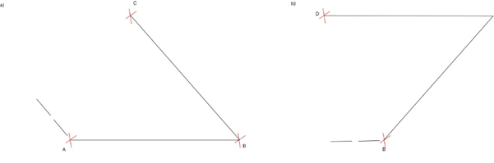

**5. Transfer the figure into your notebook and complete it to form a parallelogram. You know you need to use the protractors to draw two arcs that intersect at two points. Then, use the scale to connect the points of intersection. Finally, if pupils would use a scale to draw it they would need to add two more arcs that intersect at two additional points and connect these points as well, and you they have created a parallelogram, how would you solve this? Draw it.**

ChatGPT

To complete the figures and form parallelograms, let's break the process down step by step:

**Step 1: Understand the Parallelogram**

A parallelogram is a four-sided shape where opposite sides are equal in length and parallel. To complete the figure, we'll use the property that opposite sides are parallel and equal.

**Step 2: Drawing a Parallelogram for Part (a)**

1. **Using Point A and B**: Start by recognizing that side ABABAB needs to have a parallel opposite side.
2. **Using Point C**: We can see that side BCBCBC is already drawn. We now need to complete the opposite side of this triangle.
3. **Use a Protractor**: Measure the angle at AAA and use a protractor to draw two arcs that intersect. These arcs will show where the missing fourth point should be.
4. **Connect the Points**: After marking the intersection point with the arcs, use a ruler (scale) to connect the missing points and complete the parallelogram. The new lines will be parallel to sides ABABAB and BCBCBC.

**Step 3: Drawing a Parallelogram for Part (b)**

1. **Using Point D and B**: We see two sides DBDBDB and DADADA (dashed line). The task is to complete the parallelogram.
2. **Measure the Angle**: At point DDD, measure the angle and draw an arc to estimate the point where the fourth corner will be.
3. **Use a Ruler**: Once you have the intersection point from the arcs, connect it to complete the opposite sides of the parallelogram. These new lines will be parallel to DBDBDB and DADADA.

**Step 4: Final Steps**

* Repeat the process to ensure that all opposite sides are equal and parallel. You now have a full parallelogram for each figure.
* If you were to draw this in your notebook, using a ruler to measure the lengths and a protractor to measure the angles would help create an accurate shape.

This is how you can create and complete the parallelograms!

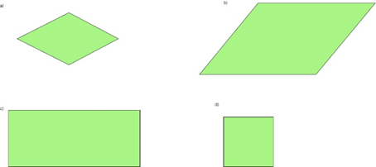  
**6. Which quadrilaterals are rhombuses? If we know that a rhombus is a quadrilateral whose all four sides are equal in length and opposite sides are parallel to each other, which quadrilaterals are rhombuses?**

ChatGPT

Let's analyze the four quadrilaterals (a, b, c, d) based on the definition of a rhombus:

A **rhombus** is a quadrilateral where:

* All four sides are equal in length.
* Opposite sides are parallel to each other.

**Step 1: Look at each shape**

* **Shape (a)**: This shape looks like a tilted square or diamond shape. Since all sides seem equal, and opposite sides are parallel, **this is a rhombus**.
* **Shape (b)**: This shape appears as a parallelogram, but the sides are not equal in length. Therefore, **this is not a rhombus**.
* **Shape (c)**: This is a rectangle, and although opposite sides are parallel, the sides are not equal in length. **This is not a rhombus**.
* **Shape (d)**: This is a square, and since all sides are equal and opposite sides are parallel, **this is also a rhombus** (note: all squares are rhombuses, but not all rhombuses are squares).

**Conclusion:**

* **Shape (a)** and **Shape (d)** are rhombuses.
* **Shape (b)** and **Shape (c)** are not rhombuses.

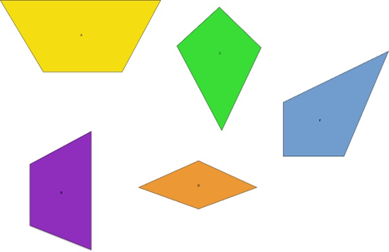  
**7. Which of these quadrilaterals are a) Kites b) Trapezoids If we know that Trapezoid is Quadrilateral with exactly one pair of parallel sides. And Kite is a Quadrilateral with two sets of adjacent congruent sides, what is kite and what is a trapezoid? Draw it and explain it.**

ChatGPT

Let's go through each quadrilateral in the image and identify which are kites and which are trapezoids based on their definitions.

**Definition Recap:**

1. **Trapezoid**: A quadrilateral with exactly **one pair of parallel sides**.
2. **Kite**: A quadrilateral with **two pairs of adjacent sides that are equal in length**.

**Step 1: Analyzing Each Shape**

* **Yellow Shape (Top Left)**: This shape has one pair of parallel sides (the top and bottom sides). This means it is a **trapezoid**.
* **Green Shape (Top Right)**: This shape has two pairs of adjacent congruent sides. The adjacent sides are equal, but it does not have any parallel sides. This makes it a **kite**.
* **Purple Shape (Bottom Left)**: This shape does not appear to have any parallel sides, and the adjacent sides are not congruent, so it is neither a trapezoid nor a kite.
* **Orange Shape (Bottom Center)**: This shape has two pairs of adjacent congruent sides, making it a **kite**.
* **Blue Shape (Bottom Right)**: This shape has one pair of parallel sides, making it a **trapezoid**.

**Final Classification:**

* **Trapezoids**: Yellow (Top Left), Blue (Bottom Right).
* **Kites**: Green (Top Center), Orange (Bottom Center).

By using the definitions of a kite and a trapezoid, this is how we can classify the shapes!

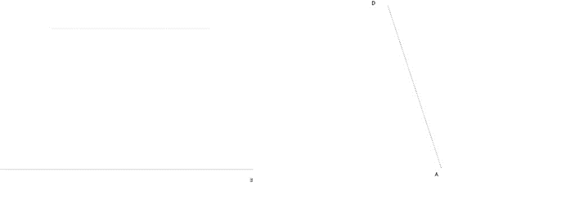

**8. Transfer the figure to your notebook and complete it to form a symmetrical trapezoid. Mark all the corner points and measure the side lengths. If we know that the trapezoid is made by drawing two parallel lines of different lengths to then form the quadrilateral, how would you solve this? Draw it.**

ChatGPT

To complete the figure and form a symmetrical trapezoid, let's go through the steps together. A trapezoid has one pair of parallel sides, and for symmetry, it will have equal slanted sides.

**Step-by-Step Guide to Complete the Symmetrical Trapezoid:**

**Step 1: Understand the Given Figure**

* The image shows the beginning of a trapezoid, with one side (likely a slanted side) drawn between points **A** and **D**.
* The dotted line suggests that this is a trapezoid in progress, with a missing side parallel to the base.

**Step 2: Drawing the Parallel Sides**

1. **Base Line**: Draw a horizontal line through point **A**. This will serve as one side of the trapezoid (the bottom).
2. **Parallel Line**: Measure a distance from **A** to **D**. Using this distance, draw a parallel line above the base, ensuring it is shorter or longer than the base, depending on the type of trapezoid you want.

**Step 3: Complete the Trapezoid**

* From the endpoints of the parallel line you just drew, connect these points back to **D** and **A**, forming slanted sides. These sides should be equal in length, as this is a symmetrical trapezoid.
* Ensure that the top and bottom lines remain parallel to each other.

**Step 4: Mark the Corners and Measure**

* Label the corners of the trapezoid as **A**, **B**, **C**, and **D**.
* Measure the lengths of all sides (both slanted and parallel) using a ruler to ensure that it is symmetrical.

**Conclusion:**

Once you complete these steps in your notebook, you will have a symmetrical trapezoid with two parallel sides and equal slanted sides.

 

**9. Complete an axially symmetrical figure. As we know, the symmetry figure is symmetric if we can divide the object into two identical parts, how would you draw this? Draw the first one, then the second figure. Task A.**

ChatGPT

To complete the axially symmetrical figures, let's go through each image step by step and apply the concept of symmetry:

**Figure 1 (Yellow Shape)**

1. **Understand the Symmetry**:
   * The yellow shape appears to be half of a larger shape, and we need to reflect it across an imaginary vertical line to complete the symmetry.
2. **Steps to Complete the Symmetry**:
   * Draw a vertical line through the center where the shape ends.
   * Reflect each point of the yellow shape across this vertical line. You should measure equal distances from the line for every point.
   * Copy the yellow shape exactly on the other side, but mirrored.

**Figure 2 (Blue Shape)**

1. **Understand the Symmetry**:
   * The blue shape appears to have been reflected across a diagonal axis. The task is to complete the symmetrical half on the other side of this diagonal.
2. **Steps to Complete the Symmetry**:
   * Draw a diagonal line that runs through the middle of the figure.
   * Reflect each part of the blue shape across this diagonal line by measuring the perpendicular distance from each point of the blue shape to the diagonal.
   * Copy the blue shape on the opposite side to complete the symmetry, ensuring that the reflected shape is identical but flipped along the diagonal.

**Final Thoughts:**

By following these steps, you will have completed both figures to be axially symmetrical. Make sure to use a ruler or symmetry tools to get precise measurements when reflecting the points!

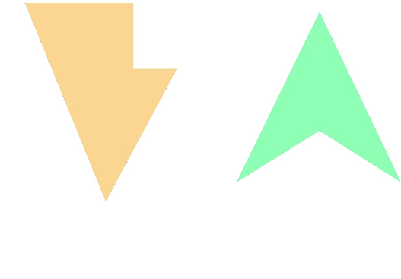

**9. Complete a) to an axially symmetric figure and b) to a point-symmetric figure. Draw it. Task B.**

ChatGPT

Let's solve these tasks one by one:

**Task (a): Complete the Figure to be Axially Symmetrical**

1. **Axial Symmetry**:
   * Axial symmetry means that one side of the shape mirrors the other side along a straight line (the axis of symmetry).
2. **Steps**:
   * Identify the line of symmetry. It seems this will be a vertical line down the center of the orange shape.
   * Reflect each point of the orange shape across this line. Make sure each reflected point is the same distance from the line as its original counterpart.
   * Copy the shape exactly, but mirrored on the opposite side.

**Task (b): Complete the Figure to be Point-Symmetric**

1. **Point Symmetry**:
   * Point symmetry means that for every point on the figure, there is an identical point directly opposite it, through a central point. This central point acts like a rotational center (180 degrees around the center).
2. **Steps**:
   * Find the center of the green shape. In this case, it looks like the center of the green triangle.
   * For every point on the green shape, reflect it 180 degrees through the center. This means you rotate each point around the center to find its corresponding point on the opposite side.
   * The completed shape will look like the original, but rotated halfway around the central point.

By following these steps, you will complete both figures with the appropriate types of symmetry!

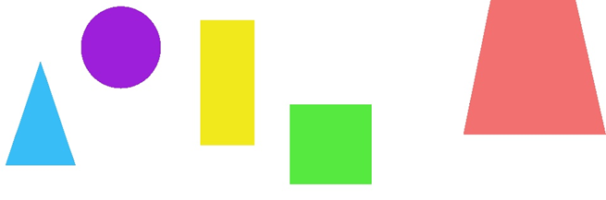

**10. Give the names of the characters. If we know that these figures represent different shapes and they are named by it, write the name of them.**

ChatGPT

Here are the names of the shapes shown in the image:

1. **Blue Shape**: This is a **triangle**.
2. **Purple Shape**: This is a **circle**.
3. **Yellow Shape**: This is a **rectangle**.
4. **Green Shape**: This is a **square**.
5. **Red Shape**: This is a **trapezoid**.

Each shape is named according to its geometric properties.